|  |  |  |  |
| --- | --- | --- | --- |
| **Team number** | 4 | **Section** | 3 |
| **Team Members** | 1. Benjamin Reyes 2. Victor Martinez 3. Diego Sanchez | | |
| **Software Name** | Mixionary (Cocktail Recipe Book) | | |

## Problem Statement

**Software Description**

The software is going to be a Cocktail Recipe Book app. The app is going to mainly be a recipe book for cocktail recipes. A place for users to be able to find other recipes or for them to make their own and upload them. Users will be able to make their own accounts and log-in to it. Users can be able to interact with one another’s recipe by rating them or favoriting them. Users can add whatever recipe they want to their recipe book. The app will have different ways to search: title, ingredient, calories.

## Product Objective

* Produce an effective cocktail recipe application that can store and sort recipes by title, ingredient, calories, favorites, ect.
* Use the abilities of the modern smartphone to take pictures of completed recipes and save them into the app itself to better represent the final product of a recipe.
* Create an effective rating system to allow users to better identify their likes and dislikes when it comes to cocktails

## Functional Requirements

This product has these features:

1. Users can have an account to themselves: Log in/out of their account. The account would just need a user and a password.
2. Be able to upload images of the created recipe
3. Be able to rate other recipes that have been created before
4. Users can be able to upload their own recipes with images
5. Able to favorite your favorite recipes
6. Search by title, ingredient, calories

## Use Cases

|  |  |  |  |
| --- | --- | --- | --- |
| **Use Case Name** | | Home User | |
| Goal | | | |
| Utilize this app in order to save and easily search up recipes at home. This application would make it significantly easier for a home user to be able to find a new hot recipe just from their home or share with the world the recipe’s they know. | | | |
| Participating Actors | | | |
| Everyday home user | | | |
| Glossary | | | |
| Define any complex concepts, abbreviations or acronyms | | | |
| Primary Flow of Events | | | |
| Trigger | | | |
| Users click on “Popular new recipe” in the main menu to find new recipes | | | |
| **Steps** | **Action** | | **System Response** |
| 1 | Clicks on Popular New Recipe | | System goes to “popular new cocktail page”(the page is going to be numbered from 1 to n. From 1 being the hottest cocktail at this instant) |
| 2 | User clicks on a specific popular new cocktail | | System goes to that specific cocktail page (It will have cocktail name with recipe and creator with other details of the cocktail) |
| 3 | While on cocktail page user clicks on “recipe” | | System will pop up a page that will contain the ingredients for this cocktail |
| 4 |  | |  |
| 5 |  | |  |
| Alternate Flow of Events (copy as many as required) | | | |
| **Alternate Trigger** | | | |
| User clicks on “save” instead of “recipe”(step 3) from the specific cocktail | | | |
| **Steps** | **Action** | | **System Response** |
| 1 | User clicks on “save” | | System will now save this recipe to the user’s “My recipes” page |
| 2 | user goes to main menu and presses my recipes | | System takes user to the user’s “my recipe” |
| *3* | user clicks on the recipe that was previously saved | | System shows user the recipe that was recently saved |

|  |  |  |  |
| --- | --- | --- | --- |
| **Use Case Name** | | Home User | |
| Goal | | | |
| To allow users the opportunity of sharing recipes from the app. Whether it is a recipe already provided or a new one that the user created and added themselves. | | | |
| Participating Actors | | | |
| User | | | |
| Glossary | | | |
| Define any complex concepts, abbreviations or acronyms | | | |
| Primary Flow of Events | | | |
| Trigger | | | |
| User clicks on "Share" button | | | |
| **Steps** | **Action** | | **System Response** |
| 1 | Clicks on Popular New Recipe | | System goes to “popular new cocktail page”(the page is going to be numbered from 1 to n. From 1 being the hottest cocktail at this instant) |
| 2 | User clicks on a specific popular new cocktail | | System goes to that specific cocktail page (It will have cocktail name with recipe and creator with other details of the cocktail) |
| 3 | User clicks “Share” | | System brings up a window with a link to the app and the specific recipe. Users can copy the link and send via text/iMessage or post it to social media. |
| 4 |  | |  |
| 5 |  | |  |
| Alternate Flow of Events (copy as many as required) | | | |
| **Alternate Trigger** | | | |
| e.g., the user clicks on "Cancel" button | | | |
| **Steps** | **Action** | | **System Response** |
| 1 | Add as many steps as needed | |  |
| 2 |  | |  |
| *3* |  | |  |

## Mockup

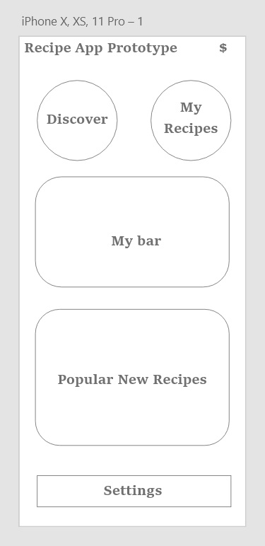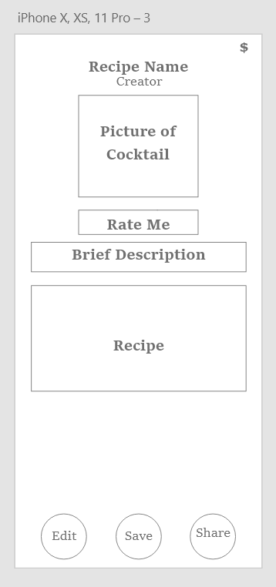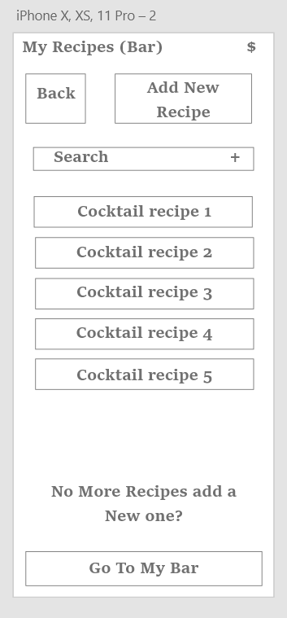

## Glossary

|  |  |
| --- | --- |
| Cocktail | Alcoholic-mixed drink |
| Users | People who use the app |
|  |  |